Articulate vs Captivate Comparison
Adobe captivate import choices
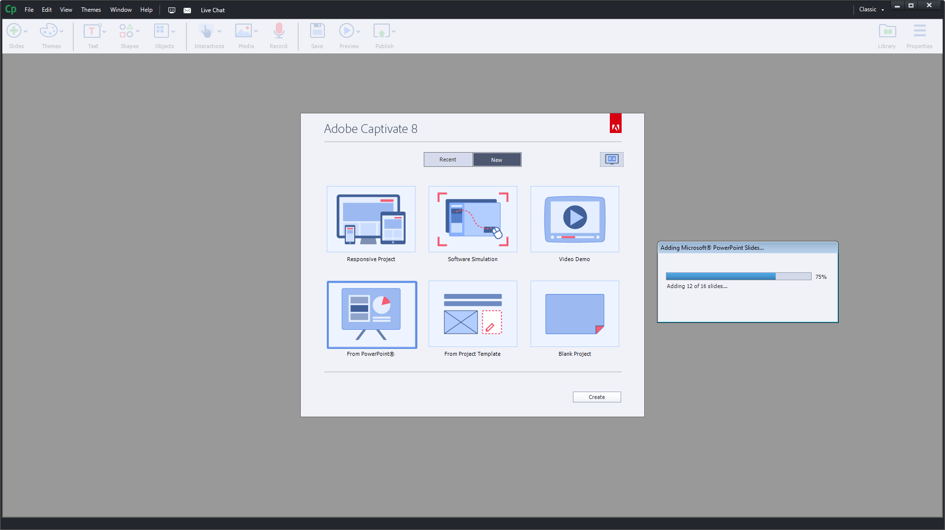
For a straight powerpoint import you can check each slide you wish to bring in
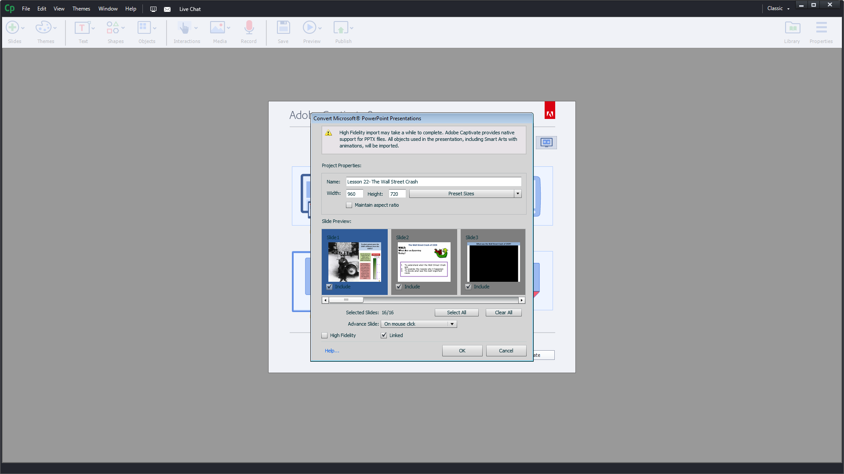
Comes in with all of the powerpoint timings and bulleted text animations
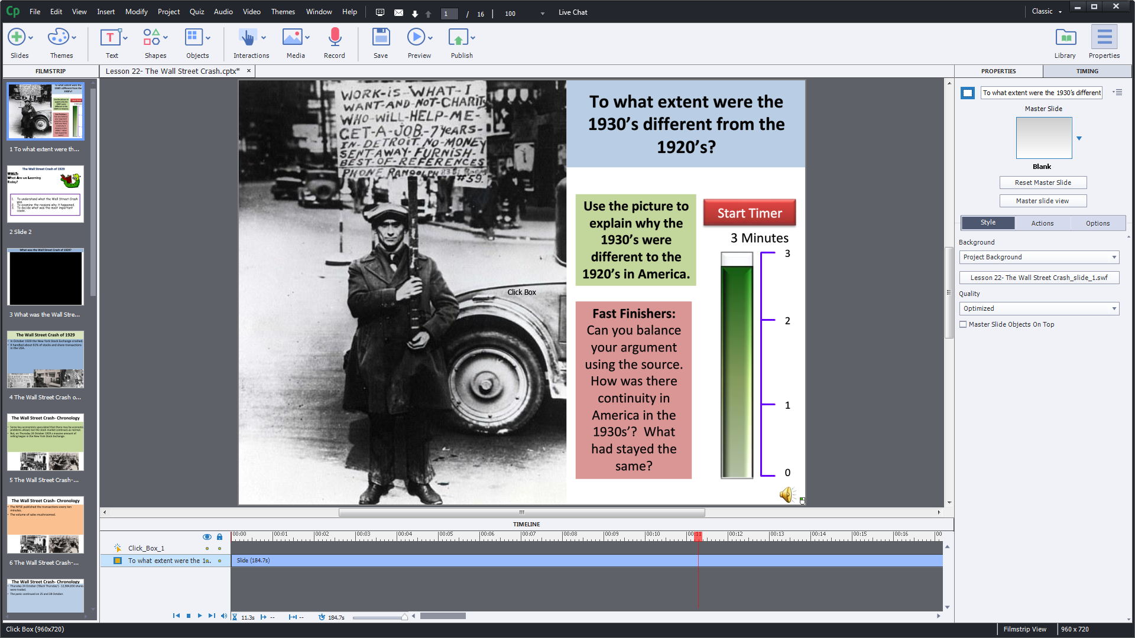
You cannot edit the text in Captivate, but you can edit the linked powerpoint file
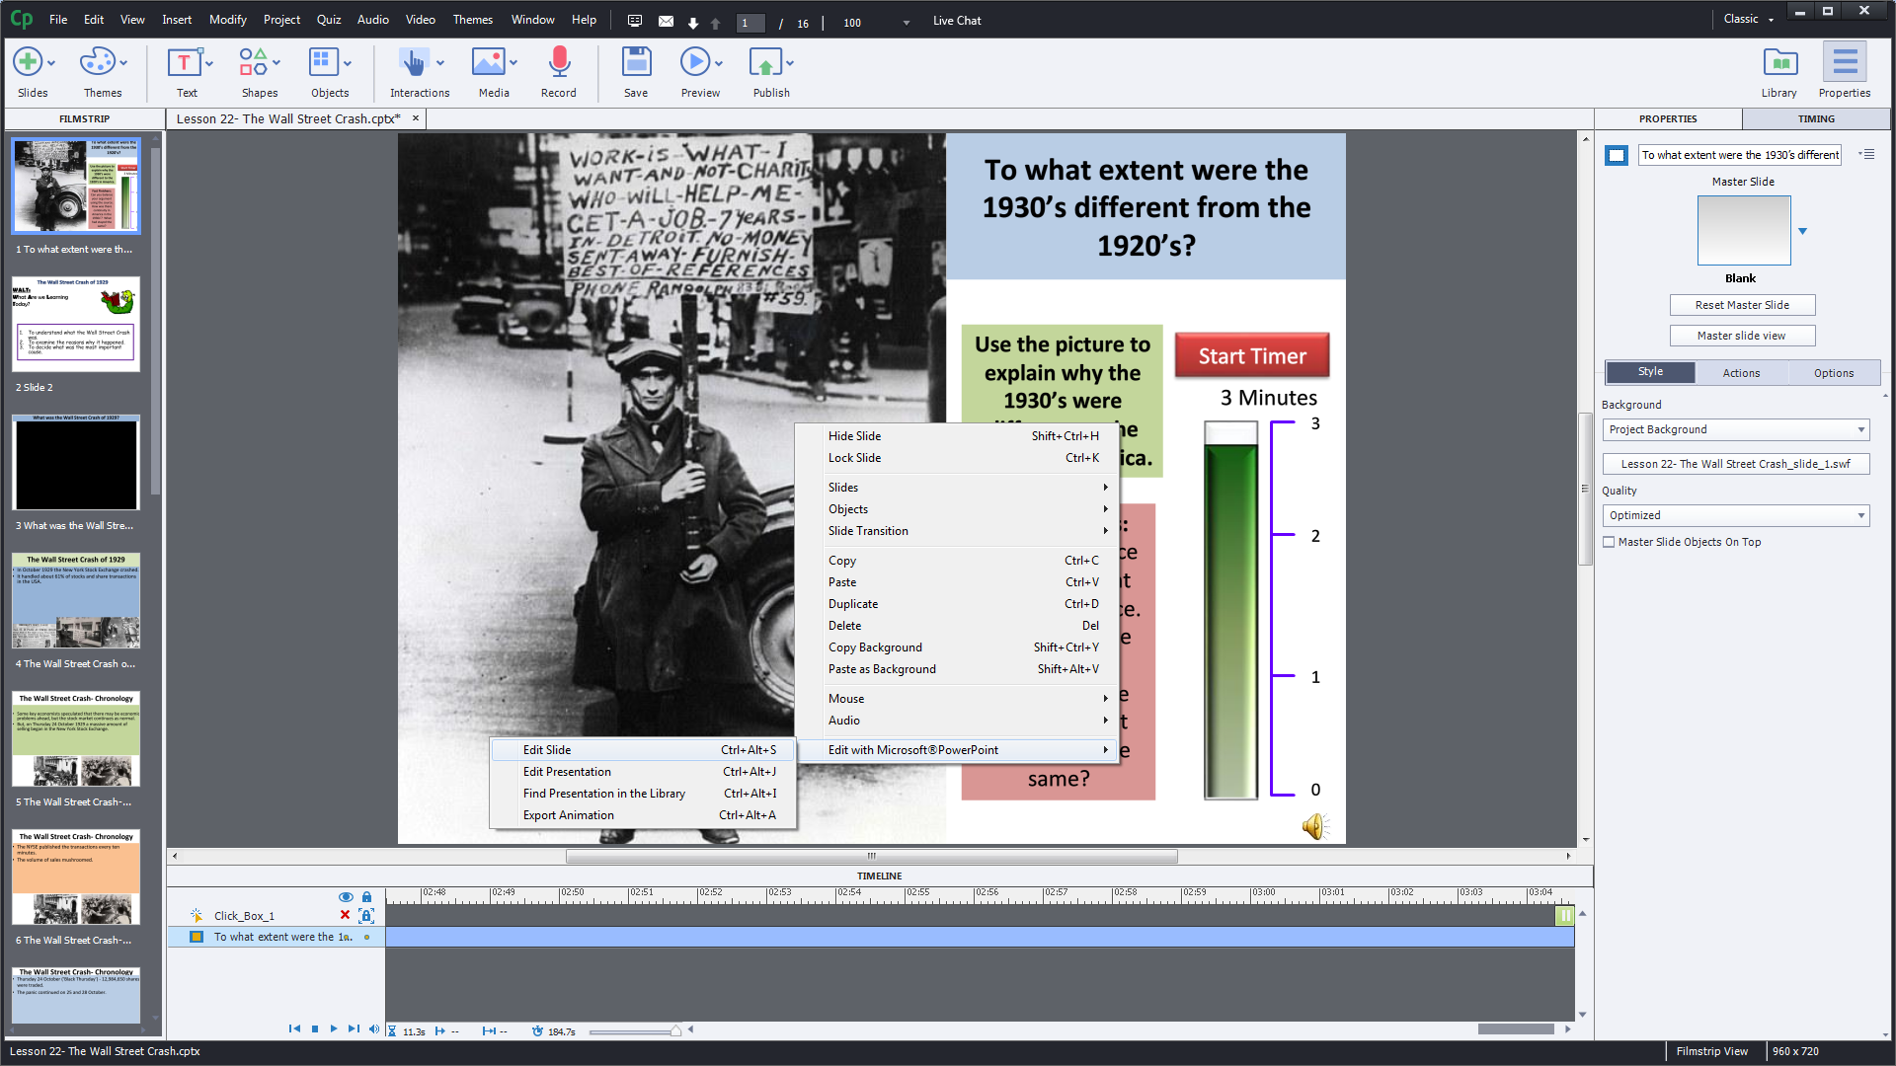
Opening up powerpoint in a pop up window so that you can adjust text, etc
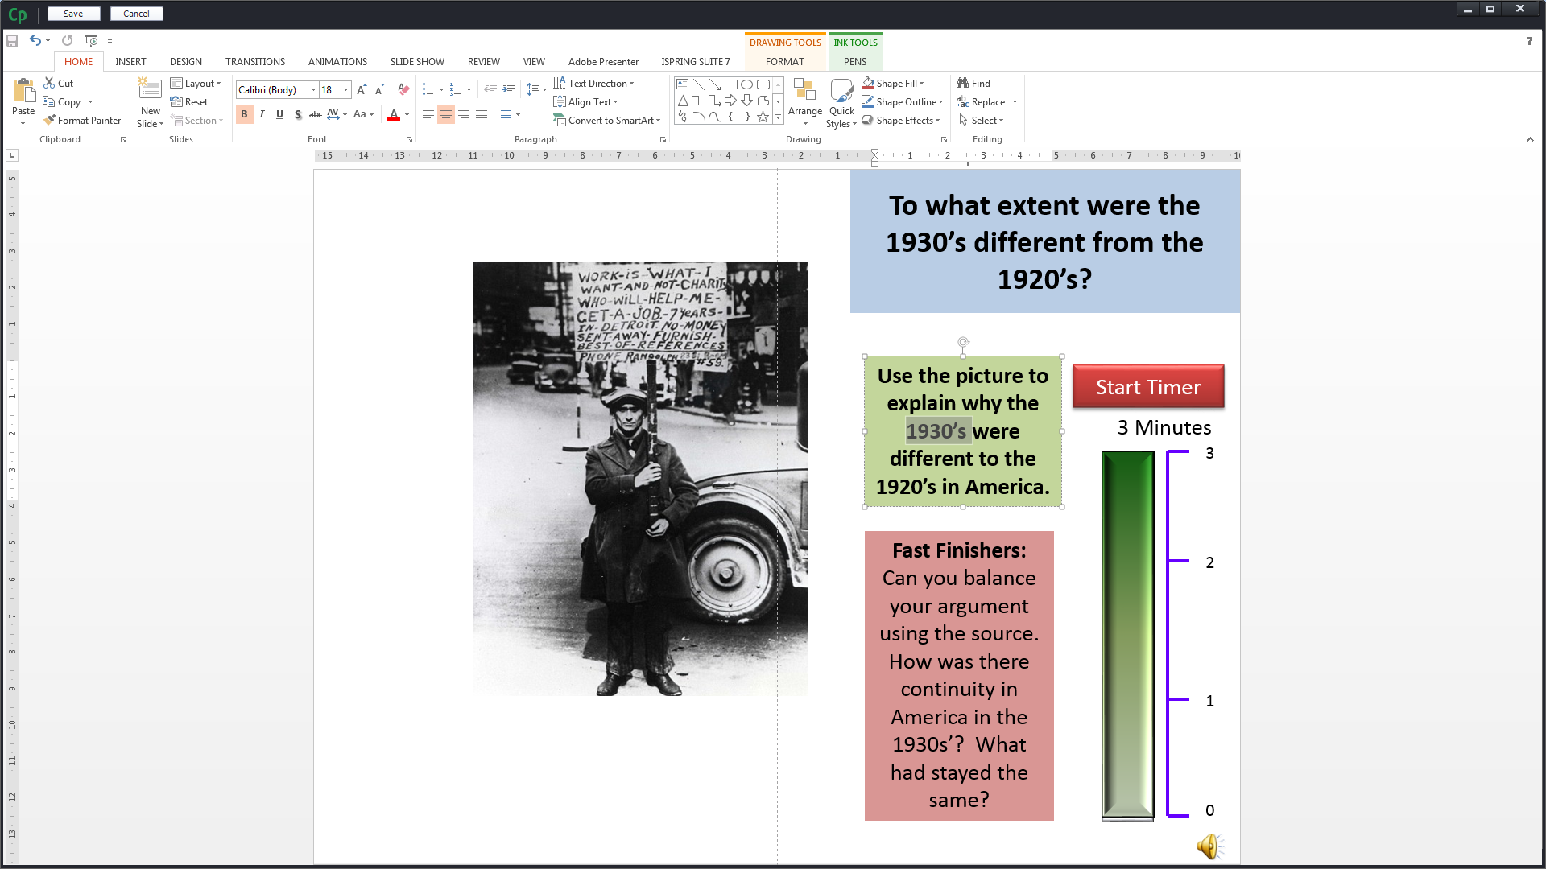
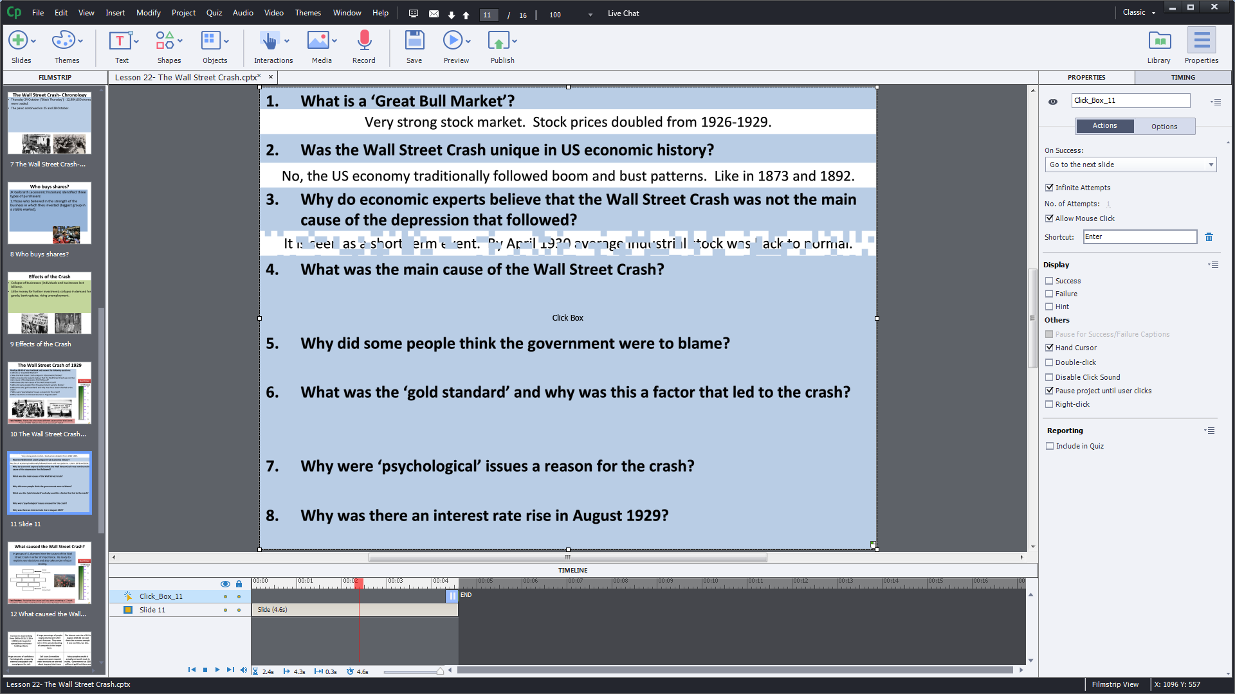
Every mouse click that advanced the ppt file has been kept and the slides have their individual timings and reveals included, but nothing is editable within captivate itself.
You can also open a ppt file and have it unlinked, but again if you want to edit the text or image or timing, you can only do so by editing the slide in captivates ‘ppt’ pop-out edit area.
So although everything imports from Powerpoint beautifully, I still have to copy and paste the individual items if I want to make them interactive or correct a spelling mistake.

Articulate
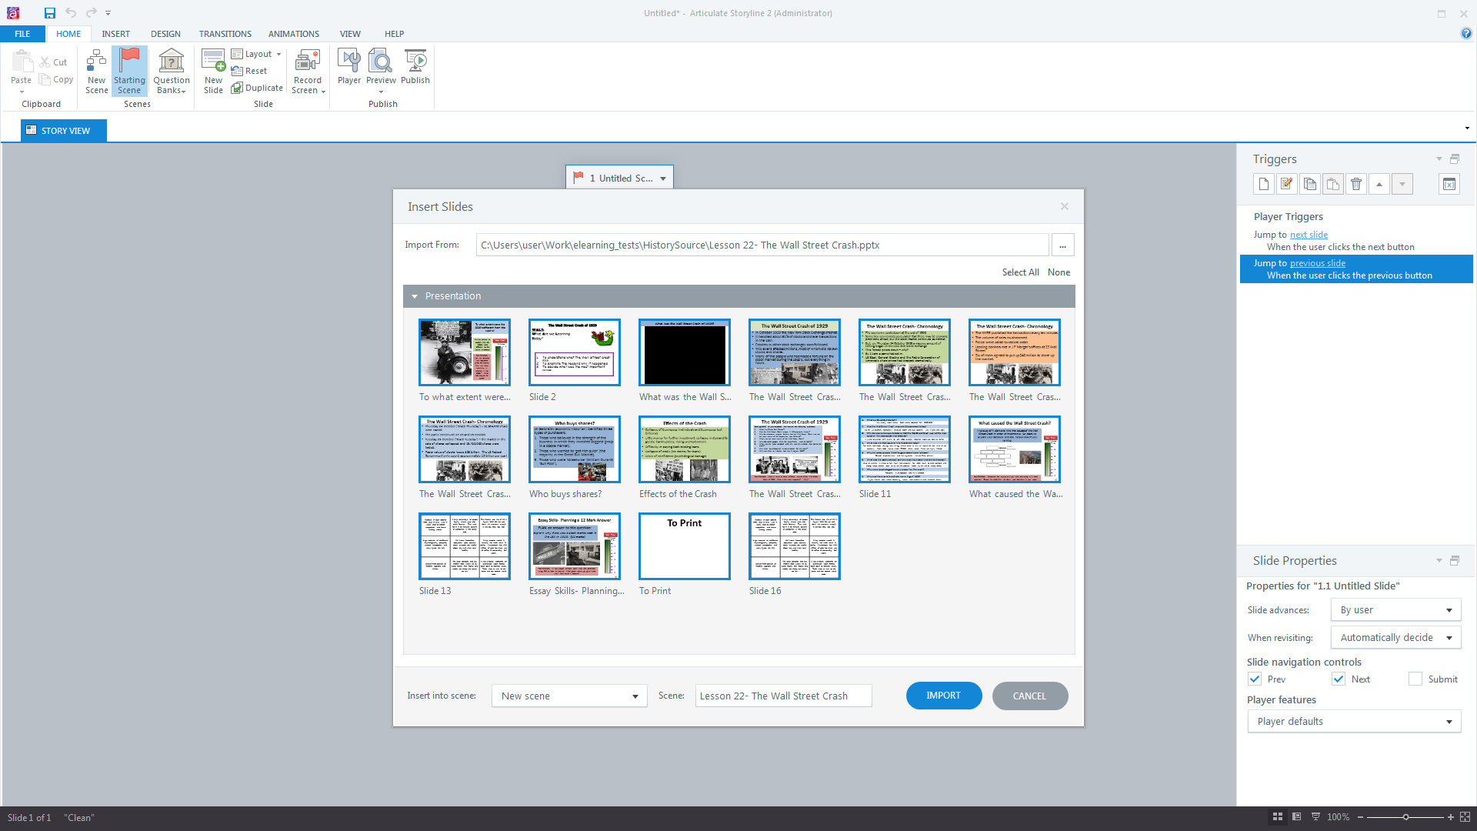
The text and images are all immediately editable with Articulate.
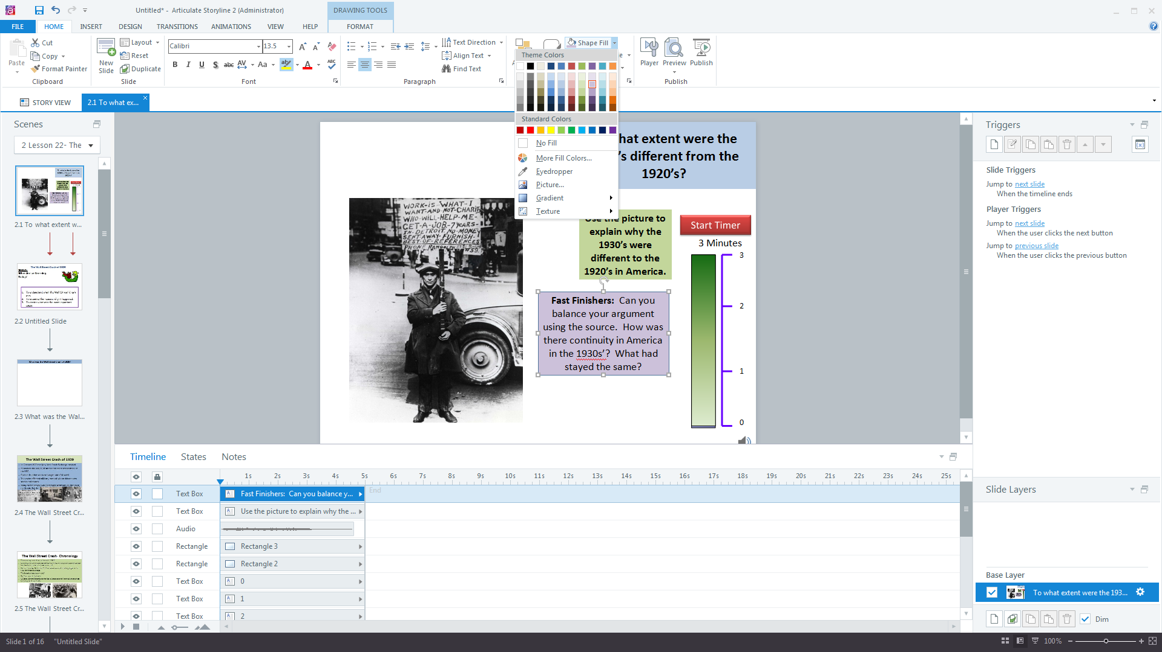
With the separate layers you can easily see all of the individual elements. Some of the timings are present, and the audio has come through.

Working in Captivate
Editing images is a much simpler operation in Storyline as all of the options appear on a right click.
Once you have found the edit image section in Captivate you find a more limited set of functions.
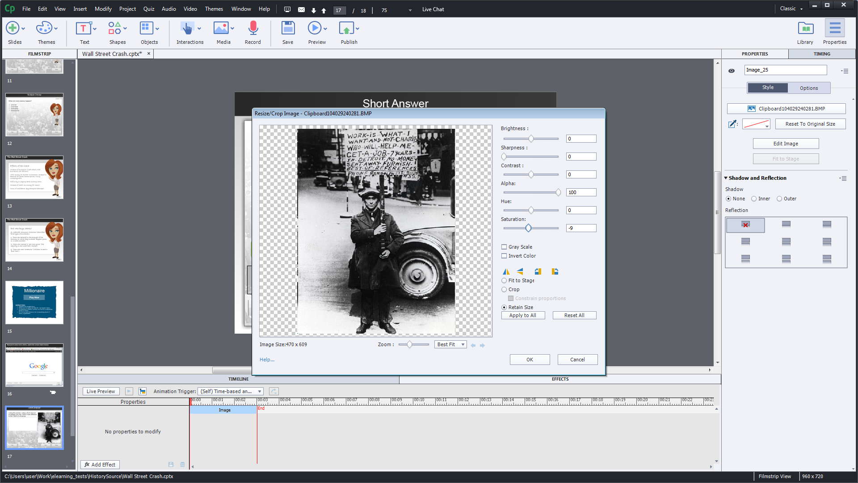

Conclusion
Importing projects from powerpoint | 5 | 2
General ease of use | 4 | 3
Quiz questions and options | 4 | 4
Image editing | 4 | 3
Recording & editing a screen simulation | 4 | 3
Customisation | 5 | 3
Output | 4* | 4*
Active online community | 5 | 2
PPT conversion Time | 3 hrs | 5hrs

Captivate has a more limiting powerpoint feel to it, basic adjustments, working within more rigid boundaries and a harder learning curve, plus there is not the community support group online.
Articulate has a better user interface, is quicker to put simple quizzes together and make minor adjustments within them, and produces e-learning that looks immediately better without having to delve too deep into the settings, and therefore quicker to pick up.
Another plus for Articulate is the very active and lively online community where they promote sharing of new templates and enhancements that will enable the apprentices to focus on the learning design aspect rather than the software obstacles.
I have looked at many comparisons and reviews between Captivate and Articulate and they both have devoted fans of each platform leading me to believe that both are fully capable pieces of software, but, I found Articulate the quickest to get going with, providing the best import from powerpoint and many ready to go good looking templates with varied uses.
In my evaluation and testing Articulate also needed the least time to produce a better looking product, with my starting point for both test projects as a supplied powerpoint.
Articulate took 3 hours to convert the project into a simple quiz and screen simulation whereas Captivate took 5 hours.
Bearing in mind that the level of digital skill the apprentices come in with will be varied from basic design knowledge down to possibly none, my concern would be that the apprentices time would be taken up with learning captivate rather than being able to get on with the wider aspects of e-learning design as they would definitely need more teaching time for the basics.
Articulate has the edge in almost all aspects in my testing and I would recommend this as the software to teach on the Digital learning Design course.

